**BANK CHURN ANALYSIS**

**Database Used - MS SQL Server DB**

This project aims to analyse bank customer data to uncover insights about financial behaviour, credit utilization, income patterns, and risk assessment. Instead of focusing on churn or retention, the project emphasizes:

The **Banking and Financial Analytics** domain revolves around using data-driven insights to optimize banking operations, enhance customer experience, and mitigate risks. Banks collect vast amounts of data from customer transactions, credit histories, and financial behaviour, which are analysed to make informed business decisions.

In this domain, various analytical techniques are used to understand customer segmentation, assess credit risk, detect fraud, and improve financial product offerings. The primary goal is to enhance financial stability while maximizing customer retention and profitability.

* **Customer Segmentation** (by age, income, education, and credit behaviour)
* **Credit Utilization & Risk Analysis**
* **Spending Behaviour & Financial Health**
* **High-Value Customer Identification**
* **Dormant & High-Risk Accounts**

By leveraging SQL queries, we can generate key performance indicators (KPIs) that help banks make data-driven decisions for personalized services, risk mitigation, and marketing strategies.

**Business Impact:**

* **Better Credit Risk Management –** Identify high-risk customers before they default.
* **Personalized Banking Services –** Offer premium services to high-net-worth individuals.
* **Marketing Optimization –** Focus on high-potential customers for financial products.
* **Enhanced Customer Retention Strategies –** Detect dormant accounts & re-engage customers.

**KPI’s Requirements:**

1. **Total Customers:**

SELECT COUNT(clientnum) AS Total_Customers FROM bank_churn_data;

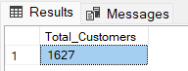

1. **Average Utilization Ratio:**

SELECT ROUND(AVG(utilization_ratio), 2) AS Avg_Utilization

FROM bank_churn_data;

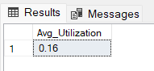

1. **Average Credit Limit:**

SELECT ROUND(AVG(credit_limit),2) AS Avg_Credit_Limit FROM bank_churn_data;

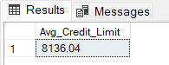

1. **Average Age:**

SELECT AVG(customer_age) AS Avg_Age FROM bank_churn_data;

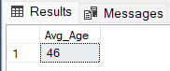

**GRANULAR ANALYSIS**

1. **Customer Distribution by Card Category**

SELECT card_category, COUNT(clientnum) AS Customer_Count

FROM bank_churn_data

GROUP BY card_category

ORDER BY Customer_Count DESC;

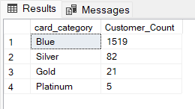

1. **Average Balance by Income Level**

SELECT income, AVG(balance) AS Avg_Balance

FROM bank_churn_data

GROUP BY income

ORDER BY Avg_Balance DESC;

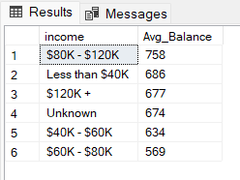

1. **Customers by Marital Status**

SELECT marital_status, COUNT(clientnum) AS Customer_Count

FROM bank_churn_data

GROUP BY marital_status

ORDER BY Customer_Count DESC;

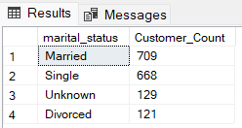

1. **Customers Segmentation by Age Group**

SELECT

CASE

WHEN customer_age BETWEEN 18 AND 25 THEN '18-25'

WHEN customer_age BETWEEN 26 AND 35 THEN '26-35'

WHEN customer_age BETWEEN 36 AND 45 THEN '36-45'

WHEN customer_age BETWEEN 46 AND 55 THEN '46-55'

ELSE '56+'

END AS Age_Group,

COUNT(clientnum) AS Total_Customers

FROM bank_churn_data

GROUP BY CASE

WHEN customer_age BETWEEN 18 AND 25 THEN '18-25'

WHEN customer_age BETWEEN 26 AND 35 THEN '26-35'

WHEN customer_age BETWEEN 36 AND 45 THEN '36-45'

WHEN customer_age BETWEEN 46 AND 55 THEN '46-55'

ELSE '56+'

END

ORDER BY Total_Customers DESC;

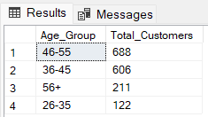

1. **Highest Credit Utilization Customers (Top 10)**

SELECT TOP 10

clientnum,

customer_age,

income,

credit_limit,

utilization_ratio

FROM bank_churn_data

ORDER BY utilization_ratio DESC;

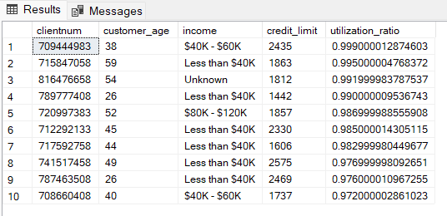

1. **Customers with High Credit Limit but Low Balance (Top 10)**

SELECT TOP 10

clientnum,

customer_age,

income,

credit_limit,

balance,

ROUND((balance * 100.0 / credit_limit), 2) AS Balance_Percentage

FROM bank_churn_data

WHERE balance < (0.2 * credit_limit)

ORDER BY Balance_Percentage ASC;

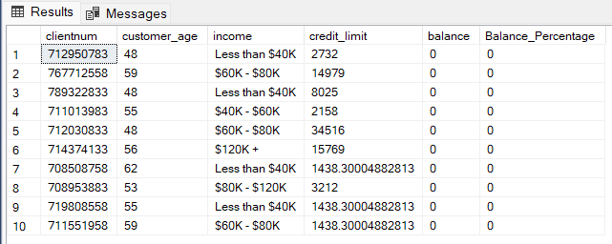

1. **Customers with the Longest Relationship (Top 10 by Tenure)**

SELECT TOP 10

clientnum,

customer_age,

months_on_book,

income,

balance

FROM bank_churn_data

ORDER BY months_on_book DESC;

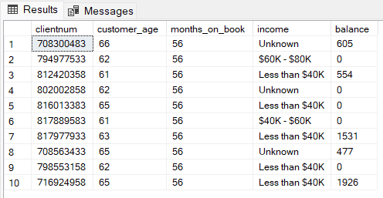

1. **Average Dependent Count by Income Group**

SELECT

income,

ROUND(AVG(dependent_count), 2) AS Avg_Dependents

FROM bank_churn_data

GROUP BY income

ORDER BY Avg_Dependents DESC;

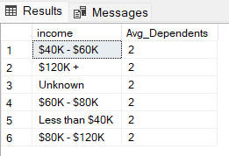

1. **Credit Utilization Index (High-Risk Customers)**

SELECT

clientnum,

customer_age,

income,

credit_limit,

utilization_ratio,

ROUND((utilization_ratio * 100.0), 2) AS Utilization_Percentage,

CASE

WHEN utilization_ratio > 0.8 THEN 'High Risk'

WHEN utilization_ratio BETWEEN 0.5 AND 0.8 THEN 'Moderate Risk'

ELSE 'Low Risk'

END AS Risk_Level

FROM bank_churn_data

ORDER BY utilization_ratio DESC;

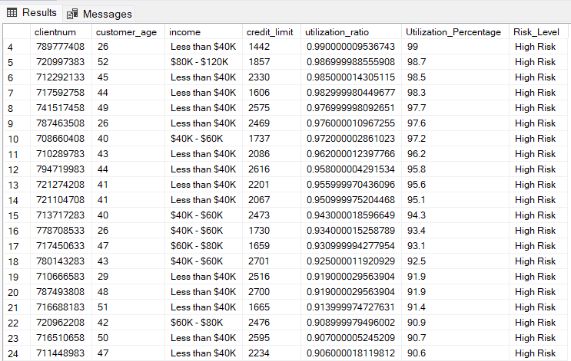

1. **Longest Relationship Customers (VIP Segmentation)**

SELECT

clientnum,

customer_age,

months_on_book,

income,

balance,

credit_limit

FROM bank_churn_data

WHERE months_on_book > 53

ORDER BY balance DESC;

